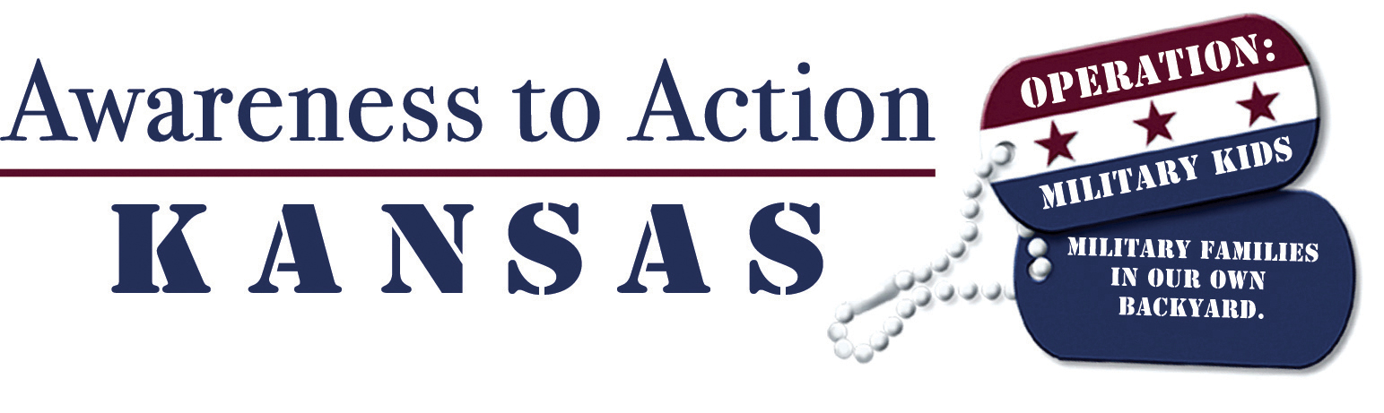

May 1, 2009

CONTACT:
Ann Domsch
Coordinator
Kansas Operation: Military Kids
(785) 532-2276
adomsch@k-state.edu

FOR IMMEDIATE RELEASE

Community Groups, Individuals Statewide Invited to Honor Military Families

MANHATTAN, Kan. — Kansas is gearing up for a statewide movement to honor and support military families during November, which is Military Family Month. Sponsored by Kansas Operation: Military Kids (OMK), Awareness to Action in Kansas invites community groups, families and individuals across the state to sign up for the program online, become educated about military families and ways to help, and then take action to celebrate local military families.

Between now and November, civic clubs, schools, youth groups and other organizations are encouraged to request the Awareness to Action program guide at www.KansasOMK.org. Using these resources, participants can educate themselves and others about the strengths of military families, the challenges they face, and ways to help out during a deployment. This knowledge will empower participants to actively support military families in their communities. Examples of ways to provide support include volunteering to help out around the house, inviting a family over for a meal, or tutoring military kids.

“Kansans are community-oriented, giving people. There are thousands of citizens who want to show their support for our military kids and families, but don’t quite know how,” said Ann Domsch, coordinator for Kansas Operation: Military Kids. “Awareness to Action gives them specific ways to help, from offering to mow a family’s yard or babysit, to compiling a list of community resources for military families who are new to the area.”

Program resources include a five-module guide containing PowerPoint presentations, fact sheets, press releases and event guides. The modules walk community members through the emotional cycle families face with deployment, how to encourage positive development among military kids, how to bolster the resilience of military families, and ways the community can help.

“These families really enrich our communities. It’s important that we recognize what they’re going through — from soldiers who are risking their lives, to spouses who take over all the responsibilities at home, to kids who must confront such big changes and uncertainties,” Domsch said.

“You can start small. Even taking a home-cooked meal to a military family is a great way to show appreciation for the contributions they make. And community groups and other civic leaders are in a position to make bigger things happen. For instance, a group can sponsor a Veteran’s Day parade, or establish scholarships for military kids to join sports teams or other activities.”

The Kansas OMK team for Awareness to Action includes representatives from Kansas 4-H; Army Reserve; Kansas Army National Guard; Kansas State University; school liaisons from Fort Riley, Fort Leavenworth, and McConnell Air Force Base; Military Source-JFSAP (Joint Family Support Assistance Program); and the Kansas American Legion.

To join Awareness to Action in Kansas today, visit www.KansasOMK.org.
###

