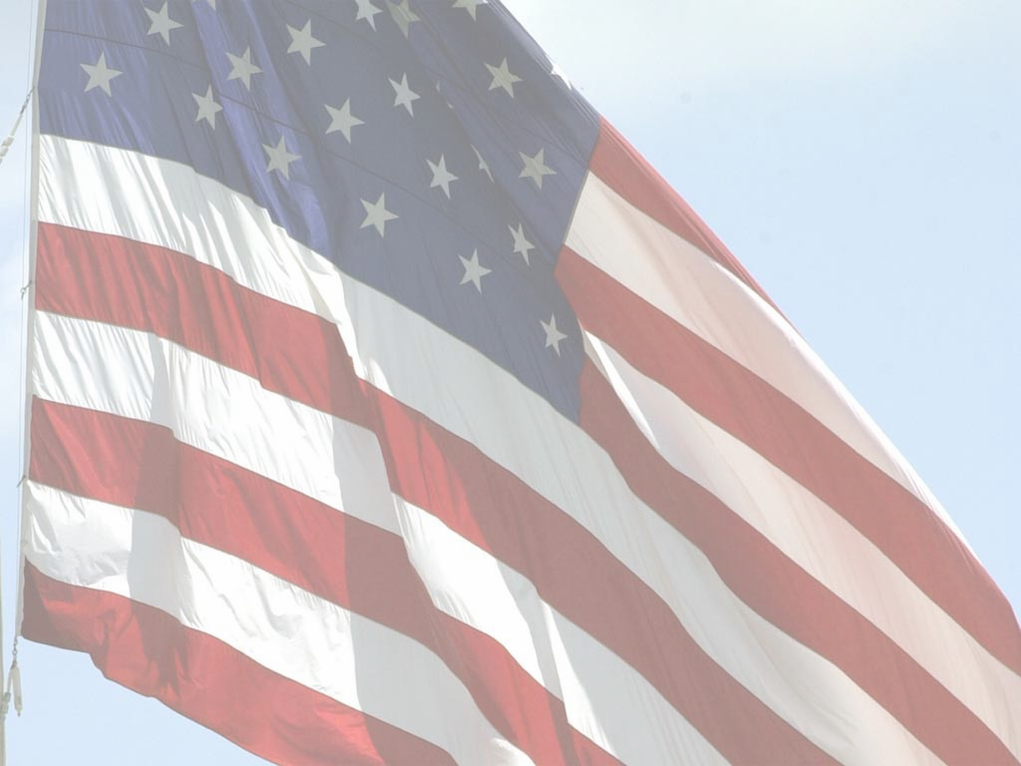
Join us at
Day Camp

Tuesday, June 10, 2014
9 a.m. to 3 p.m.
Pottorf Hall
Riley County Fairgrounds
Manhattan, Kansas

Spend the day with us making new friends, learning new things and most of all having a ton of fun! Lunch and snacks will be provided.

Day Camp is open to all military connected youth, ages 7 to 12 years of age. Military connected is any child whose parent is Active Duty, National Guard, Army Reserve, Air Guard or any other branch of the military.

There is no registration fee to attend, but we ask that you pre-register by June 3 by sending an e-mail to Julie Riniker, jriniker@ksu.edu including:
Date and Site of Day Camp
Child Participant’s Name and Age
Julie will send confirmation of registration along with a participation form that must be completed and returned prior to the day of camp.

For more information contact:
Ann Domsch, OMK Project Coordinator
adomsch@ksu.edu
785-532-2276

Day Camp is sponsored by Operation Military Kids (OMK) and Riley County 4-H. OMK is the U.S. Army's collaborative effort with America's communities to support children and youth in military families. OMK helps build local networks of community partners throughout the state to implement a broad array of educational and support programs wherever military children and families live.

The Kansas Operation Military Kids partnership is a shared initiative of the
U.S. Army Child, Youth, and School (CYS) Services and funded by the
Army National Guard and Army Reserve in collaboration with Kansas
State University and K-State Research and Extension.

